In this document, we demonstrate how to process, explore, and model text data—specifically patent abstracts—using a combination of NLP techniques and topic modeling.
You'll set up your environment, load and preprocess the data, extract features, build and interpret topic models, and visualize. By the end, you'll have a reproducible pipeline suitable for large-scale text analysis in Colab.

- Set up your Colab environment
Before diving into data analysis, install and prepare all necessary libraries. This ensures consistency and reproducibility across runs.
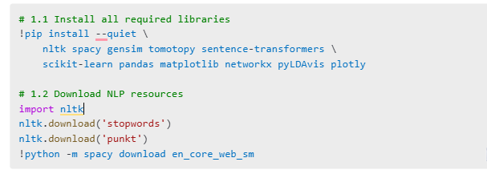

- Load the abstracts data
Load your dataset of patent abstracts into a pandas DataFrame. Verify the shape and column names to confirm successful ingestion. Ensure you have at least an abstract column.

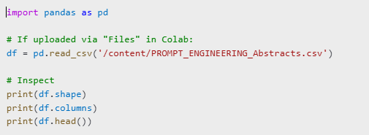

- Preprocess & tokenize abstracts
Clean and tokenize text by lowercasing, removing non-alphanumeric characters, filtering stopwords, and lemmatizing. This prepares the data for feature extraction and modeling.
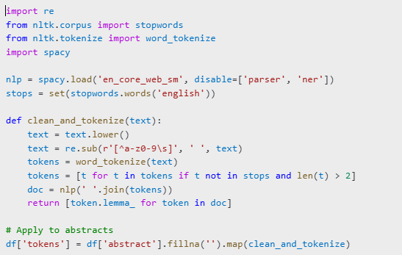

- Vectorize abstracts
Convert tokens into numerical representations. We demonstrate both TF–IDF for sparse feature extraction and pre-trained sentence embeddings for dense representations.

4.1 TF–IDF
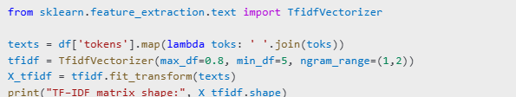

4.2 Embeddings (sentence-BERT)
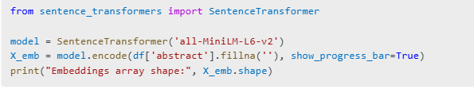
- Topic Modeling with LDA
Use gensim’s LDA to uncover latent themes. We build a dictionary and corpus from lemmatized tokens, train a 10-topic model, and inspect top words per topic. We refined num_topics parameter to improve coherence. (refined to 8, 12, and 15). When we refined it to 8, the optimal set of topics emerged.

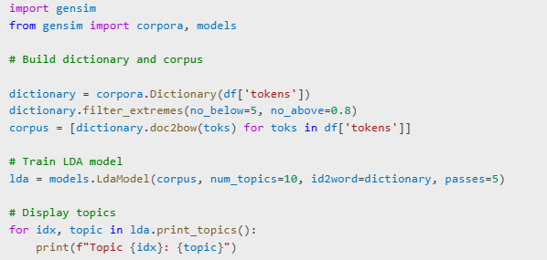
Visualize with pyLDAvis
Use pyLDAvis to explore topic-term relationships in an interactive visualization, allowing deeper inspection of topic distributions and overlaps.
